Flag
Country:

Delegate:

School:

Committee:

Official Language:

Head of State:

Type of Government:

Population:

GDP:

Official Religion:

Borders:

Historical Allies:

Historic Enemies:

Internal Problems:

External Problems:

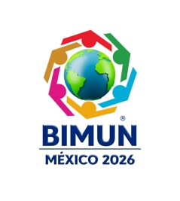

UN Participation:

Universal Declaration of Human Rights:

Topic:

Introduction to the committee:

Background:

Current situation:

Proposals (3 minimum):
*They have to be listed and to have a semicolon at the end of each one.
*It is required to add an example of another proposal that was already approved by the UN

References (5 minimum):
*This has to be in APA format.

*Everything has to be in Times New Roman 12, the paragraph spacing has to be of 1.5, indentation (or 5 spaces) and justified text.

